***MUSIC Recommendation System-In Details***

Anirban Chakraborty

11601580

Department Of Computer Science And Engineering,

Lovely Professional University

[**anirbanchakraborty456@gmail.com**](mailto:anirbanchakraborty456@gmail.com)

Avinash Kumar

11606805

Department Of Computer Science And Engineering,

Lovely Professional University

Aditya Paliwal

11606600

Department Of Computer Science And Engineering,

Lovely Professional University

Dande Lokeswara Reddy

11602543

Department Of Computer Science And Engineering,

Lovely Professional University

***Abstract*:The rise of the Internet rendered it much easier to obtain valuable knowledge from all the public material efficiently. The enormous amount of data needs structures for efficient retrieval of knowledge. Recommendation services direct consumers to fascinating items in a wide variety of available choices in a personalised manner. Computer methods and strategies that include recommendations for helpful things for a customer are recomended systems (RSs). This paper discusses three specific methods to suggest systems, including collaborative- filtering (CFs), content based filtering, and hybrids recommendation systems, which could be found in numerous ecommerce websites. We will quickly summarize every form of advantages as well as drawbacks and discuss such Recommender Systems (RSs) implementations in specific fields. In this project we developed a Recommendation system for musics.**

**INTRODUCTION**

Over recent decades, as Twitter, Amazon, Netflix and a number of other web platforms have expanded, recommendation mechanisms over our lives have become more popular. In our daily online journeys the programs suggested today are unavoidable, from ecommerce (suggesting the customers articles that could attract them) to site ads (suggesting the best material for consumers, meeting their wishes).

Very broadly speaking, recommender systems are algorithms that offer users with related things (such as movies for watching, text for reading, goods for purchasing, etc.).

In certain sectors, recommendation systems are very essential as they can provide an overwhelming amount of revenue whether they are effective or can even separate them significantly from competitors. A couple years earlier Netflix initiated a competition (the "Netflix award"), in order to create a recommendations program that performed higher than its algorithm, with a reward of 1 million dollars to be earned, to show the value of recommendation systems.

The following components are a standard framework for recommendation systems:

* candidate generation
* scoring
* re-ranking

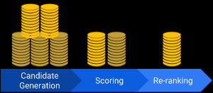The method begins with an immense body and produces a far smaller subset of candidates in this first level. In Youtube for example, the nominee generator reduces to hundreds or thousands trillions of images. With the massive scale of the corpus, the model will test questions rapidly. Different candidate generators may have a single pattern, each nominating a specific subgroup of candidates.

Last ranking, another model grades and classifies the candidates to choose the amount of objects to show for the customer (in the order of 10). Since this model tests a fairly limited subset of objects, a more robust approach focused on specific queries may be used.

Eventually, certain restrictions for the final classification will be taken into account in the framework. The program for example excludes products the consumer has directly refused or improves fresher material value. Reclassification will therefore ensure equity, freshness and fairness.

Two kinds of recommendations are commonly used:

* home page recommendations : The reviews on the homepage are tailored to a customer depending on their common preferences. Single consumer sees different advice.

If you go to the Google Play Apps homepage, you may see something like this:

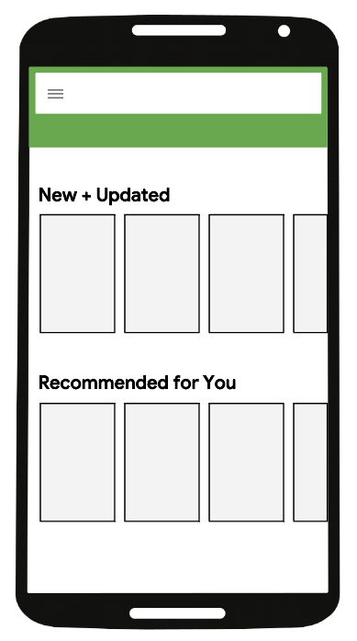

* related item recommendations : As the name means, such products are identical to a single object. Consumers who visit a tab of an app will display a panel of programs, such as other mathematics and science software, in Google Play's case.

In short, it learns the interests of users and display it automatically by some methods discussed below.

**APPROACHES**

There vare three major approaches in Recommendation Syatem. These are:

* **Collaborative Filtering:** The approach utilized for Recommending applications is mutual screening (CF). There are two senses, a specific one and a more common, for collaborative filtering.

In the older, broader context, collaborative based filtering is a process of gathering tastes or taste data from multiple users (collaborating) for automated predictions (filtering) of the desires of a consumer. The idea of this collective filtering method is that whether a individual A has the same view on a topic as an individual B, A is more probable than a randomly selected person to have a view of B on a particular subject. A shared screening advisory program for TV preferences, for example, might anticipate which TV shows the consumer needs a partial description of his interests (likes or dislikes) for the consumer. Notice that these are user-appropriate forecasts, but that other uses need details. That varies from the smoother method of assigning each element of interest an overall (non-specific) rating, for example depending on the voting amount.

In a more general sense, collaboratory filtration includes the filtering process for information or trends, using techniques which require collaboration between multiple officers, points of view, sources of evidence, and so on. Different forms of data, such as: knowledge gathering and monitoring, such as geological mining, environmental sensing on broad areas or multi-sensor data, financial based data, such as financial linked service organizations which combine various finance services and online transactions and web technologies, where consumer details become a priority etc., have been collaborated through filtering techniques. The remainder of this article centers on shared user-data filtering, while many large systems may still be subject to such strategies and approaches.

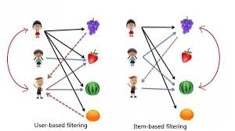Fig: Collaborative Filtering

* **Content Based Filtering:**Content Based Filtering, also known as semantic filtration, proposes products based on a similarity of the quality of the things with the customer profile. The contents of each object are seen as a series of definitions or phrases, usually the words in a text. The consumer profile is shown on the same terms and is generated by the review of the nature of the things the customer has viewed.

There are some challenges when a content-based filtering scheme is applied. Words can be automatically or manually allocated first. A system must be chosen to delete such words from products as words are allocated automatically. Secondly, the words should be interpreted in such a manner as to allow clear connections between the user profile and the posts. Second, you have to pick a learning algorithm which will learn the user profile based on the things you see and make predictions based on this user profile.

Text records are the most important type of knowledge utilized by content-based filtering systems. A common term sorting technique extracts specific terms from records. The vector spaced model and latented semantine indexing-method describe documents in a multi-dimensional space by the two approaches used in these words.

Relevance input, genetic algorithms and neural networks are among the learning methods used to know a user profile. Bayesian classifier. These methods of learning can also describe documents via the vector space model and the latent semanticized indexing. Many forms of education often reflect an individual profile in the same multidimensional space as one or more vectors, which enables the contrast between documentation and identities. Others methods of learning such as the Bayesian Classifier and the neural networks do not use this space.

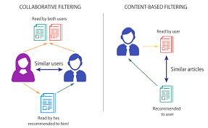

Fig: Content Based Filtering

* **Knowledge Based Recommendation System:** Knowledge Based Recommendation System (expertise-driven advisory programs) are a specific form of guidance program focused on clear knowledge on the topics, customer needs and suggestion requirements. Both mechanisms are relevant in situations that do not implement alternate solutions like shared filters or content-driven filters.

The non-existenceof cold start (ramp-up), a big strength in knowledge-based suggestion systems. A similar drawback is the possible shortage in information gained by the need to specifically identify suggestion awareness.

Know-how-based suggestion mechanisms are also conversational. In the sense of a feedback process, consumer expectations and desires are elicited. The difficulty of the element environment, in which it is always difficult to express all consumer desires at once, is a significant explanation for the conversational existence of information base recommender. Additionally, consumer expectations are not generally understood at the start, but rather created in the sense of a decision sitting.

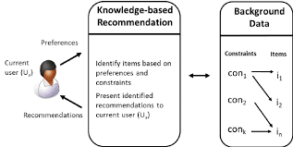Fig: Knowledge Based Recommendation System

* **Hybrid Recommendation:** Collaborative based filtering and content-based screening are used as the foundation of hybrids recommender schemes. Such remove the constraints of indigenous CF strategies. It improves the efficiency of the forecast. It overcomes essential CF problems including knowledge sparsity and failure. Thanks to two or more simple methods of implementing schemes, various forms of integrating them in the context of a modern hybrid method have been suggested. Yet they are more complicated and costly to implement. Many commercial advertisement schemes, for example, are mixed, as is the Google News Advice Program.

Advantages: ̈ The composite method attempts to solve the shortcomings of the other methods by incorporating two or three strategies.

Disadvantages:· They are difficult to introduce because they incorporate two or three strategies to effective ads with added sophistication.

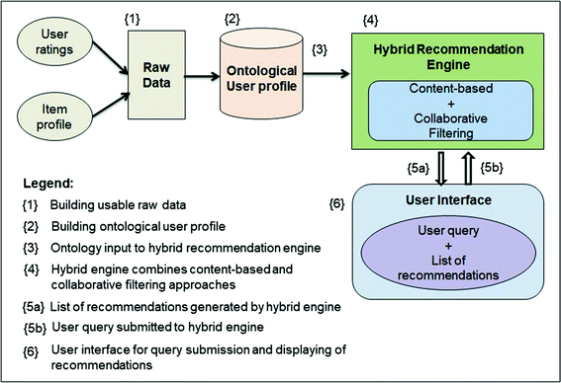

**APPLICATIONS**

There are plenty of applications of Recommendation System. Some useful and well known application are as follows:

* Real Life Applications-Music

Pandora

Ganna

Google Play Music

* Real Life Applications-Dating

OKCupid

Marriage Matrimony

Tinder

* Real Life Applications-Movie

Netflix

Amazon Prime

Hotstar

* Real Life Applications-Eccomerce

Amazon

Flipkart

Jabong

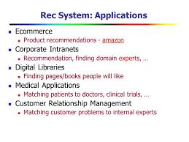

**RESULTS**

The whole project is carried out in jupyter lab. There are many outputs found. These are:

First output where the users will listen song of there choice

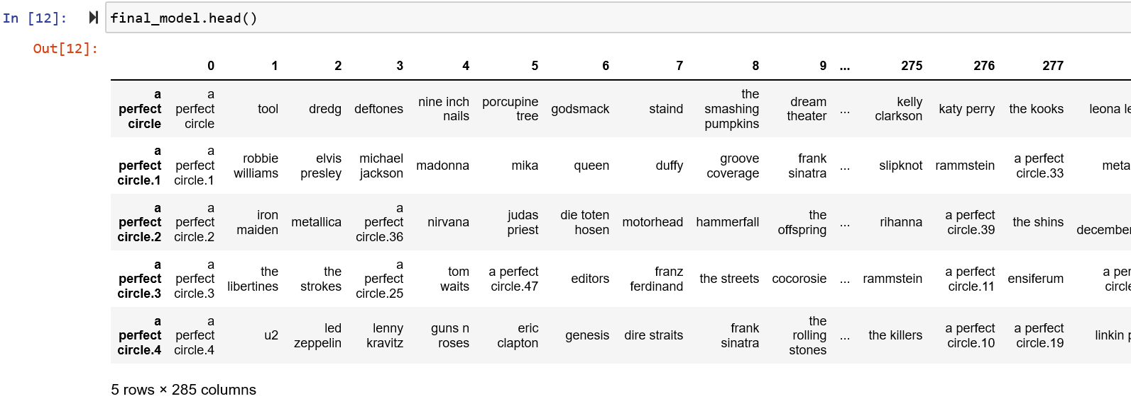

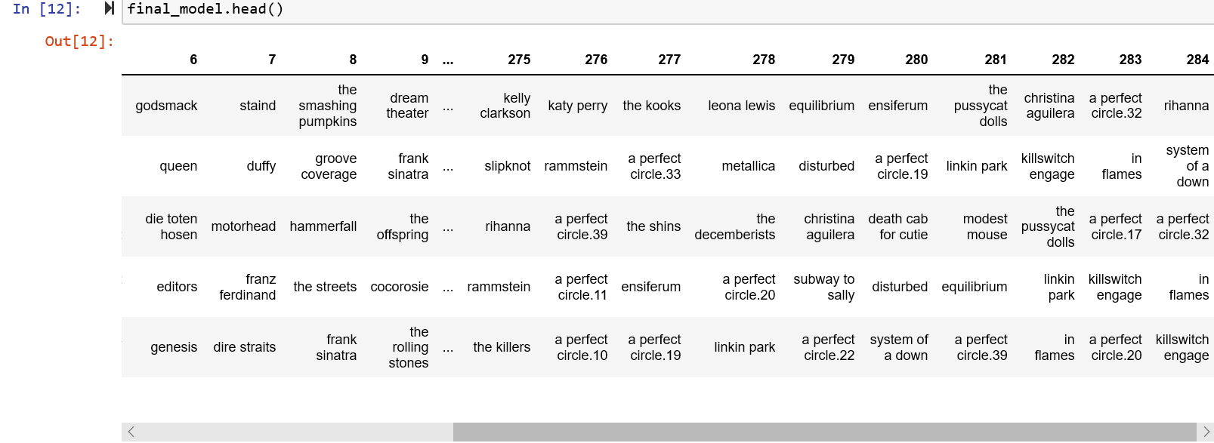

After that recommendation will be done based on the interest of the users:

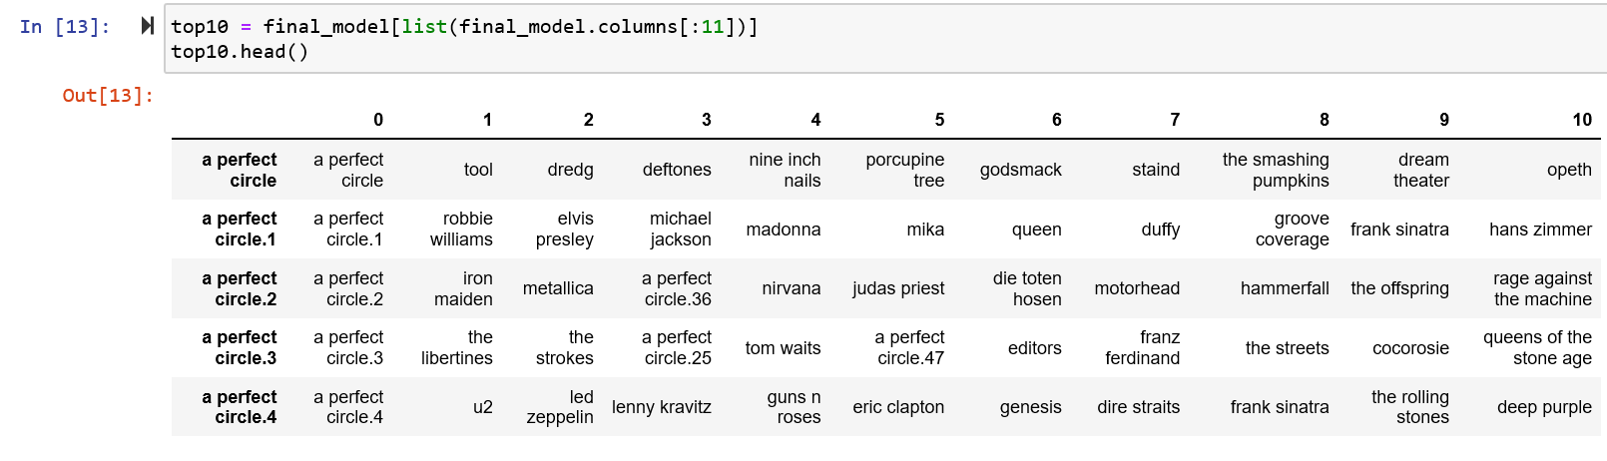

**CONCLUSION**

The three schemes proposed have their benefits and disadvantages. The other will balance much of the shortcomings of each solution. A successful recommender will be willing from time to time to provide constructive and appropriate suggestions and to include alternate suggestions to overcome user's frustration while the same things are included in the recommendation list. The frameworks for potential decisions will be complex and profiles will be modified in real time. That plus the convergence of specific profile ensures that there is a strong need for processing resources, bandwidth etc. All current algorithms and techniques are fairly complex in memory, resulting in long device processing time and network latency.

Therefore, it would also be the technology strategy to eliminate all modern methods and strategies that may reduce machine memory sophistication.

**REFERENCES**

1. Francesco Ricci and Lior Rokach and Bracha Shapira, Introduction to Recommender Systems Handbook, Springer, pages 1-35, 2011,

2. Resnick, P., Varian, H.R., Recommender systems. Communications of the ACM 40(3), Pages 56–58, 1997.

3. Herlocker, J.L.; Konstan, J.A.; Terveen, L.G.; Riedl, J.T., Evaluating collaborative filtering recommender systems. ACM Transaction on Information Systems 22(1), Pages 5–53, 2004,

4. Terveen, Loren; Hill, Will, "Beyond Recommender Systems: Helping People Help Each Other". Addison-Wesley. Page 6, 2001.

5. An integrated approach to TV Recommendations by Red Bee Media.

6. Factor in the Neighbors: Scalable and Accurate Collaborative Filtering.

7. Xiaoyuan Su, Taghi M. Khoshgoftaar, A survey of collaborative filtering techniques, Advances in Artificial Intelligence archive, 2009.

8. Peter, Brusilovsky, the Adaptive Web. ISBN 978-3-540-72078-2., Page. 325, 2007.

9. Pasquale Lops, Marco de Gemmis, Giovanni Semeraro, Content-based Recommender Systems: State of the Art and Trends, Recommender Systems Handbook, Springer, Pages 73-105, 2011.

10. Burke, R.: Hybrid web recommender systems. In: The AdaptiveWeb, Springer Berlin / Heidelberg, Pages. 377–408, 2007.

11. Kernel Mapping Recommender System Algorithms, [www.sciencedirect.com/science/article/pii/S0020025512002587](http://www.sciencedirect.com/science/article/pii/S0020025512002587).

12. Google News Personalization: Scalable Online Collaborative Filtering.